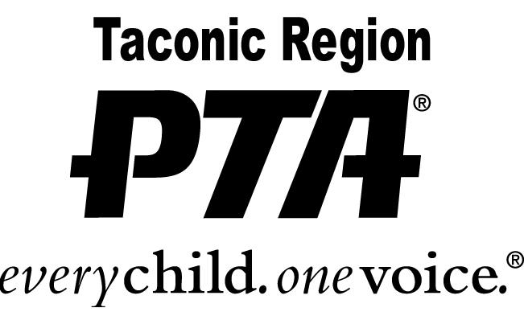

LEADERSHIP AWARD
In Honor of Jane Skrzypek

2021 – 2022 Application Instructions

Leadership is a process of influence – the ability to direct the problem-solving process of others. To lead is to direct, encourage, inspire and coordinate. A good leader develops personal skills and encourages and trains new leaders who will follow.

PURPOSE:
To recognize an exceptional leader in your PTA who, by his or her actions, inspires others to volunteer and assume leadership positions. The NYS PTA established this award in 1991 to honor Jane Skrzypek.

CRITERIA:
- Completed applications - Taconic and NYS PTA - https://nyspta.org/home/pta-leaders/awards-and-recognitions/jane-skrzypek-award/
- The nominee must volunteer above and beyond the scope of his/her PTA position
- Must exhibit leadership qualities that encourage others to participate and volunteer.
- To be eligible, the nominee must be a member of a PTA/PTSA in good standing and volunteer through the PTA.

DEADLINE:
The completed application and letters of recommendation must be postmarked by
April 22, 2022.

MAIL TO: Christine Lent, Taconic PTA Awards Chairperson
24 Stonehedge Drive
Poughkeepsie, NY 12603

Questions: email Christine at awards@taconicpta.org

